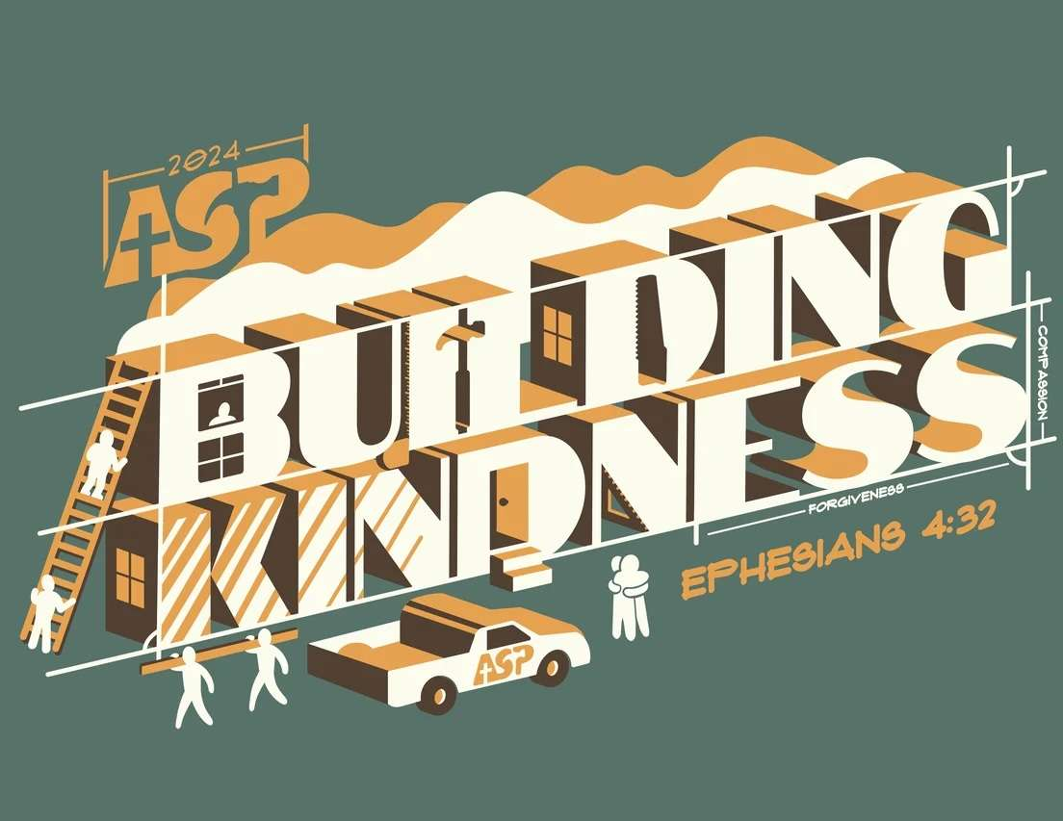
St. Giles Appalachia Service Project 2024
Date ________

Dear________________,
This coming summer I am very excited to (again) be participating in the Appalachia Service Project (ASP) with St. Giles Parish. ASP is a home repair relationship ministry to low-income families in Central Appalachia, including some of the poorest counties in the United States. I will be spending a week in Kentucky, along with 150 teens and adults from the St. Giles community.
I am fortunate to be able to participate in this life-changing experience where I will meet and learn from the people who live in this region of the country. I am excited to make the journey this summer and to continue the ASP mission of helping others. Our group is now meeting and planning for our trip July 20 – 27, 2024. We have several fundraisers planned to raise money to cover our travel expenses, program fees, and home repair supplies.
In addition to our time, each participant is making a financial contribution to the trip. This is where I need your help. I am asking you to donate to this important ministry by becoming a part of my support team. When we are assigned to a county, I will send you a link to our ASP Facebook page so you can follow our projects during the week.
Any amount donated is greatly appreciated and helps make our trip possible. To keep up with our fundraising goals, please donate by June 15, 2024.
Please know that I appreciate your support as I set out on this meaningful mission. If you’d like to learn more about our St. Giles ASP group, you can visit www.stgilesparish.org/asp. I feel very fortunate to be part of a community that is so willing to serve others.
Thank you for helping me help others.
Peace,

Name, phone and email
ST. GILES APPALACHIA SERVICE PROJECT
Please fill out this form and return it with your donation to St. Giles ASP, 1025 Columbian, Oak Park IL, 60302 OR
donate online at www.stgilesparish.org/asp. Donations are 100% tax deductible.
NAME: ______________________________________
ADDRESS: ______________________________________________________________
EMAIL: ________________________________________
AMOUNT OF DONATION: $ _____________
ASP Participant’s name to credit ________________________________
“Be kind and compassionate to one another, forgiving each other, just as in Christ,
God forgave you.” Ephesians 4:32

